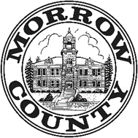_____________________________________________________________________________________Morrow County Veterans Services
P.O. Box 560
Irrigon Oregon 97844
(541) 922-6420

The passing of a loved one can be an extremely difficult, emotional time. Unfortunately, there are usually many decisions to be made and actions to be taken by the surviving spouse and/or children, especially if the loved one was a veteran of U.S. military service.
While there are numerous benefits, honors, and services to claim in your veteran’s name, it’s helpful to be prepared and organized to ensure his or her service is properly honored.
Spouse or family member
Request Veterans Use Only Death Certificate from Funeral director- there is no charge, ask that it be sent to Morrow County Veteran Services.
We can also assist with National Cemetery burial.
Role of VSO-
The Veterans Service Representative can assist with Burial Benefits that the veteran may be entitled to. If the veteran has been enrolled with us as a Veterans Service Representative, we will have a copy of the veterans DD-214 (Military Discharge), which is required to apply for burial and/or surviving spouse benefits.
Upon receiving the Death Certificate the VSO notifies VA health care to no longer send medications or schedule the veteran for health care exams.
AND notifies VA Compensation or Pension Dept. to stop VA benefits- this avoids an overpayment that would otherwise have to be repaid. The veteran or spouse is entitled to receive a payment for the month of the veterans passing.
If needed, we work closely with the funeral director to provide a copy of the DD-214 to assist with Veteran burial honors.

Call Morrow County Veterans Services 541-922-6420 We’re here for you.
VA benefits can be complicated, we’re here to help you navigate the process.

Veterans Burial Benefits

Ask the funeral director to provide a Veterans Use Only Death Certificate to your Morrow County Veterans Service Representative (VSR). Your VSR will assist you in applying for VA burial benefits & survivor benefits if applicable.

VA National Cemeteries Burial in a VA national cemetery is available for eligible Veterans, their spouses and dependents at no cost to the family and includes the gravesite, grave-liner, opening and closing of the grave, a headstone or marker, and perpetual care as part of a national shrine. For Veterans, benefits also include a burial flag and military funeral honors. Family members and other loved ones of deceased Veterans may request Presidential Memorial Certificates.
VA operates 131 national cemeteries, of which 71 are open for new casketed interments and 19 are open to accept only cremated remains. Burial options are limited to those available at a specific cemetery but may include in-ground casket, or interment of cremated remains in a columbarium, in ground or in a scatter garden. The funeral director or the next of kin makes interment arrangements by contacting the National Cemetery Scheduling Office or national cemetery in which burial is desired. VA normally does not conduct burials on weekends. Gravesites cannot be reserved; however, VA will honor reservations made under previous programs.
Private Cemeteries: Before ordering a Veterans Headstone, check with the cemetery to ensure that the Government-furnished headstone or marker will be accepted. There are no VA benefits available to spouses and dependents buried in a private cemetery.

Burial Flags: VA will furnish a U.S. burial flag to memorialize:
- Veterans who served during wartime or after Jan. 31, 1955.
- Veterans who were entitled to retired pay for service in the Reserve or National Guard, or would have been entitled if over age 60.
- Members or former members of the Selected Reserve who served their initial obligation, or were discharged for a disability incurred or aggravated in the line of duty, or died while a member of the Selected Reserve.
Military Funeral Honors: Upon request, the Department of Defense (DoD) will provide military funeral honors consisting of folding and presentation of the United States flag and the playing of “Taps.” A funeral honors detail consists of two or more uniformed members of the armed forces, with at least one member from the deceased’s branch of service.
Family members should inform their funeral director if they want military funeral honors. DoD maintains a toll-free number (1-877-MIL-HONR) for use by funeral directors only to request honors. VA can help arrange honors for burials at VA national cemeteries.

The Department of Veterans Affairs (VA) furnishes upon request, at no charge to the applicant, a Government headstone or marker for the unmarked grave of any deceased eligible Veteran in any cemetery around the world, regardless of their date of death.
A Government-furnished headstone or marker may be provided for eligible Veterans who died on or after Nov. 1, 1990 and whose grave is marked with a privately purchased headstone. A Government-furnished medallion may be provided for eligible Veterans who served on or after Apr. 6, 1917 and whose grave is marked with a privately purchased headstone or marker.

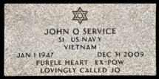
Flat Grave Markers: Granite or Marble The flat granite and flat marble grave markers are 24 inches long, 12 inches wide, and 4 inches thick. Weight is approximately 130 pounds. Variations may occur in stone color; the marble may contain light to moderate veining.
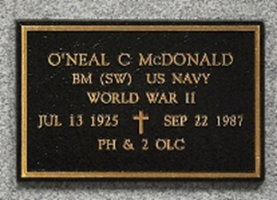
Flat Grave Marker: Bronze The flat bronze grave marker is 24 inches long, 12 inches wide, with 3/4 inch rise. Weight is approximately 18 pounds. Anchor bolts, nuts and washers for fastening to a base are furnished with the marker. The government does not furnish a base.
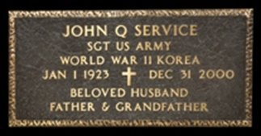
Niche Marker: Bronze The niche marker is 8 1/2 inches long, 5 1/2 inches wide, with 7/16 inch rise. Weight is approximately 3 pounds. Mounting bolts and washers are furnished with the marker.

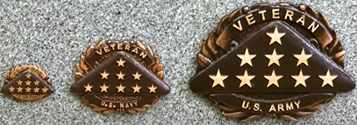
Bronze Medallions: Small, Medium, or Large
The bronze medallion is available in three sizes: Small (2"W x 1-1/2"H x 1/3"D), Medium (3-3/4"W x 2-7/8"H x 1/4"D), or Large (6-3/8"W x 4-3/4"H x 1/2"D). Each medallion is inscribed with the word "VETERAN" across the top and the branch of service at the bottom.

A Presidential Memorial Certificate (PMC) is an engraved paper certificate signed by the current president. Find out how to request a certificate to honor the military service of a Veteran or Reservist.
You may be eligible for a Presidential Memorial Certificate if you meet both of these requirements.
Both of these must be true: The Veteran or Reservist is eligible for burial in a national cemetery, and You’re the next of kin, family member, or close friend of the Veteran or Reservist (or an authorized service representative for a family member or friend of the Veteran or Reservist)

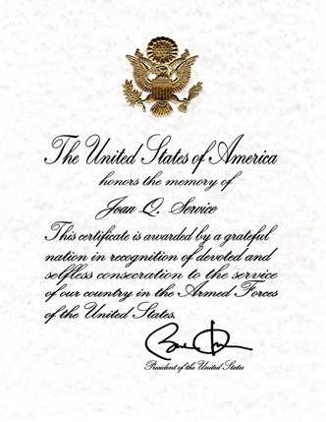

Reimbursement of Burial Expenses: -
Eligibility Requirements
- You paid for a Veteran's burial or funeral, AND
- You have not been reimbursed by another government agency or some other source, such as the deceased Veteran's employer, AND
- The Veteran was discharged under conditions other than dishonorable, AND
- The Veteran died because of a service-related disability, OR
- The Veteran was receiving VA pension or compensation at the time of death, OR
- The Veteran was entitled to receive VA pension or compensation, but decided not to reduce his/her military retirement or disability pay, OR
- The Veteran died while hospitalized by VA, or while receiving care under VA contract at a non-VA facility, OR
- The Veteran died while traveling under proper authorization and at VA expense to or from a specified place for the purpose of examination, treatment, or care, OR
- The Veteran had an original or reopened claim pending at the time of death and has been found entitled to compensation or pension from a date prior to the date or death, OR
- The Veteran died on or after October 9, 1996, while a patient at a VA-approved state nursing home.

(Note: Annual increase in burial and plot allowances)
Service Related Death: VA will pay a burial allowance up to $2,000 if the Veteran’s death is service-connected. In such cases, the person who bore the Veteran’s burial expenses may claim reimbursement from VA.
In some cases, VA will pay the cost of transporting the remains of a Veteran whose death was service-connected, to the nearest national cemetery with available gravesites. There is no time limit for filing reimbursement claims in service-connected death cases.
Non- Service- Related Death: VA will pay up to $796 toward burial and funeral expenses for deaths on or after October 1, 2019 (if hospitalized by VA at time of death), or $300 toward burial and funeral expenses (if not hospitalized by VA at time of death), and a $796 plot-interment allowance (if not buried in a national cemetery). Veterans who, at time of death, were entitled to receive pension or compensation or would have been entitled if they were not receiving military retirement pay.
Eligibility also may be established when death occurs in a VA facility, a VA-contracted nursing home or a State Veterans nursing home. In cases in which the Veteran’s death was not service-connected, claims must be filed within two years after burial or cremation.

