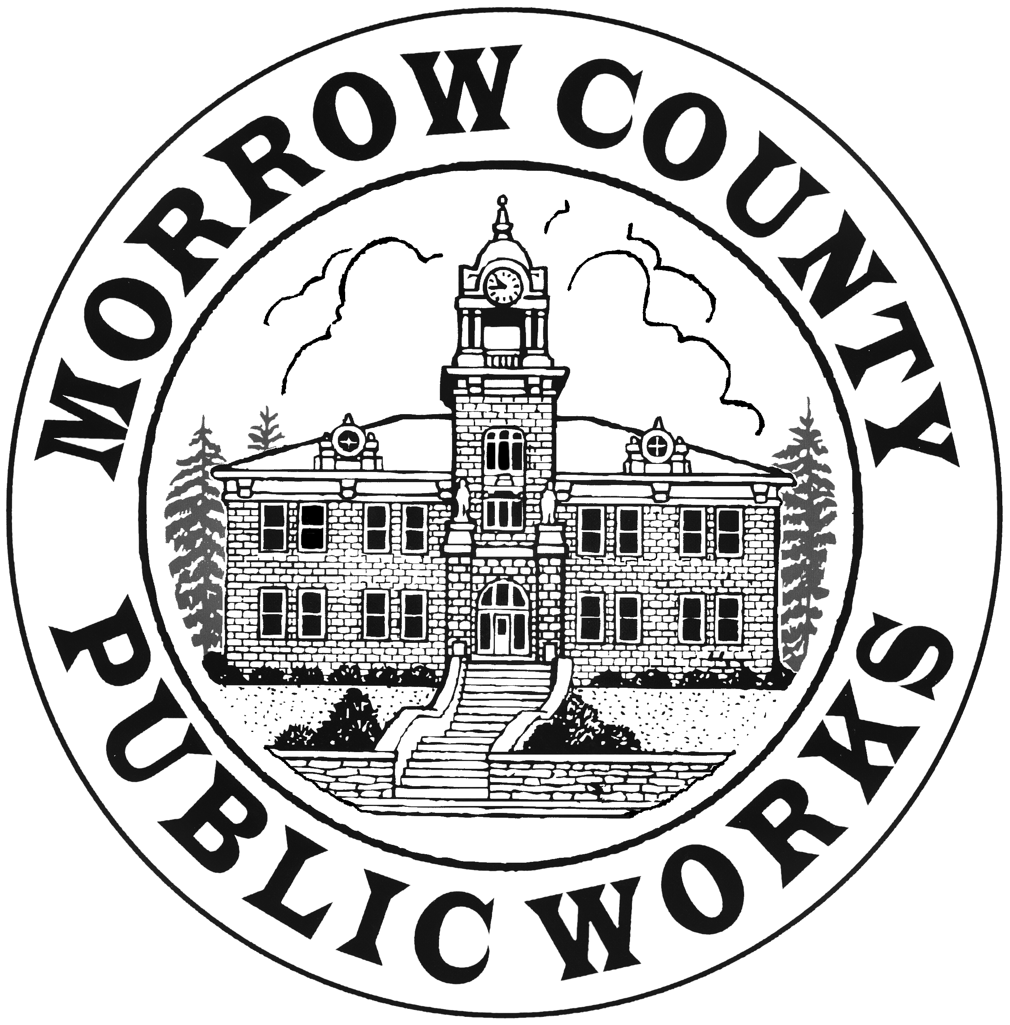 | PUBLIC WORKS DEPARTMENT  Airport General Maintenance Road Department Parks Transfer Stations
365 W. Highway 74 Matt Scrivner Eric Imes
P.O. Box 428 Public Works Director Asst. Road Master
Lexington, OR. 97839
Phone: (541) 989-9500 Sandi Pointer Kirsti Cason
Fax: (541) 989-8352 Management Asst. Administrative Asst.

REQUEST FOR BIDS

Morrow County Parks Department is requesting bids for a high flow snow blower to attach to a C238 New Holland track loader. All questions are to be directed to Greg Close parks manager at mcparksmgr@co.morrow.or.us /541-240-1741.

Bids are due by November 30th at 4:00pm.
- Bids mailed must be marked “Morrow County Parks Snow Blower Bid” and mailed to P.O. Box 428 Lexington, Oregon 97839
- Bids Hand delivered must marked “Morrow County Parks Snow Blower Bid” and delivered to 365 west Highway 74 Lexington, Oregon 97839
- EMAILED bids can be sent to mscrivner@co.morrow.or.us but must be mark in the subject line “Morrow County Parks Snow Blower Bid” as it will not be opened until after 4:00pm on November 30th.
All bids must include quoted price, attachment brochure, wiring configuration to C238 and estimated delivery date if selected as bidder.

Specifications of attachment:
- 84-inch-high flow intake double auger snow blower
- 36-inch intake with 5/8-inch-high flow couplers
- 24 to 36-inch minimum rotary fan blade
- 14 pin adapter for a new Holland C 238 track loader
- Heavy duty skid shoes
- Pressure relief on hydraulic motor
- Poly gasket chute
- Hydraulic driven chute rotation

