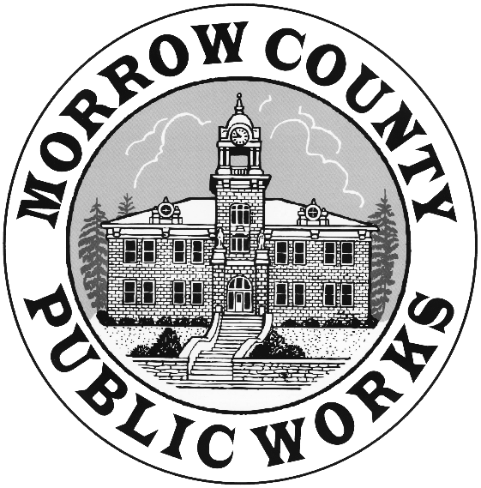

**REQUEST FOR QUOTES**

**CLASS C ASPHALT HOT MIX (as specified below)**

**CSS-1H TACK OIL (or equivalent per specifications below)**

**APRIL 2020 – NOVEMBER 2020**

**QUOTES DUE:**

**Monday April 13th. 2020 – 3:00pm**

**Morrow County Public Works**

**P. O. Box 428**

**365 West Highway 74**

**Lexington, Oregon 97839**

**ATTN: Eric Imes -** [**eimes@co.morrow.or.us**](mailto:eimes@co.morrow.or.us)

**THIS IS A REQUEST FOR QUOTES TO SUPPLY (at supplier’s location) Class C Asphalt Hot Mix and CSS-1H Tack Oil**

***INSTRUCTIONS TO PROPOSERS:***

IP-1 **Time and Place for Receiving Quotes**

1. Quotes for the herein described materials will be received by Morrow County Public Works on or before Monday April 13th. 2020, 3:00 p.m., P.S.T.
2. Quotes must be received at the Morrow County Public Works office, P.O. Box 428, 365 West Highway 74, Lexington, OR. 97839 on or before Monday April 13th. 2020, 3:00 p.m., P.S.T.
3. Quotes must be in a sealed envelope marked “Asphalt Quote”.
4. Quotes will be opened Monday April 13th. 2020, 3:00 p.m., P.S.T. at the Morrow County Public Works Office, 365 West Highway 74 Lexington, Oregon.

IP-2 **Scope of Materials**

1. Supplier shall furnish to Morrow County Public Works at suppliers location, Class C Asphalt Hot Mix and CSS-1 Tack Oil as described below:

* Class C Mix 64-28 Liquid Asphalt

No more than 25% RAP (Reclaimed Asphalt Pavement)

0% RAS (Recycled Asphalt Shingles)

* Tack Oil CSS-1H or equivalent per specifications below

|  |  |  |
| --- | --- | --- |
| **Test** | **Test Result** | **Method** |
| Viscosity | 20 - 100 | ASTM D7496 |
| Sieve test, % | 0.1 | ASTM D6933 |
| Particle Charge | positive | ASTM D7402 |
| Residue by distillation | 60 min. | ASTM D6997 |
| Penetration, 77°F, 100 g, 5 sec. | 20-60 | ASTM D5 |
|  |  |  |

1. Morrow County estimates quantities of Class C Mix at a minimum 8600 tons and a maximum 26,000 tons during this time frame.

IP-3 **Supplier Detail**

* Location of Plant __________________________________________
* Cost per ton Class C Asphalt hot mix ___________________________
* Cost per ton CSS-1H Tack Oil _________________________________

IP-4 **Right to Reject Offers**

Morrow County may reject any offer not in compliance with all prescribed public procurement procedures and requirements, and may reject for good cause any or all offers upon a finding by the County that it is in the public interest to do so.

IP-5 **Contract Award**

1. Quotes will be evaluated by a committee appointed by the Public Works Director. The contract will be awarded to the quote deemed most advantageous to Morrow County. Quotes will be evaluated with consideration of turn around trucking time to the job site location.
2. A decision to award the contract will be made in its entirety to a single supplier within ten business days of the opening of submitted quotes. Award of the contract will be made according to timelines available to the Board of Commissioners.
3. Morrow County reserves the right to accept or reject any or all offers and waive any informalities and irregularities in offers.