https://linkprotect.cudasvc.com/url?a=https%3a%2f%2fsecuremailbox.cambiahealth.com%2fenduser%2fCambia%2fen%2fregistration.html%3fkey%3daiixnghn8vizlapwg1iet4y0553tkb70&c=E,1,KhjfjK91tw-lRZPovis7c2JueUsN4LLhPavm8gURLb5yFBVHLR2mxH_eJFnh719GNWPxF4LViaKU32KOZqCWBbkwKt0bTbzx98163aHIUjXzl0uQdphR&typo=1|kwolff@co.morrow.or.us

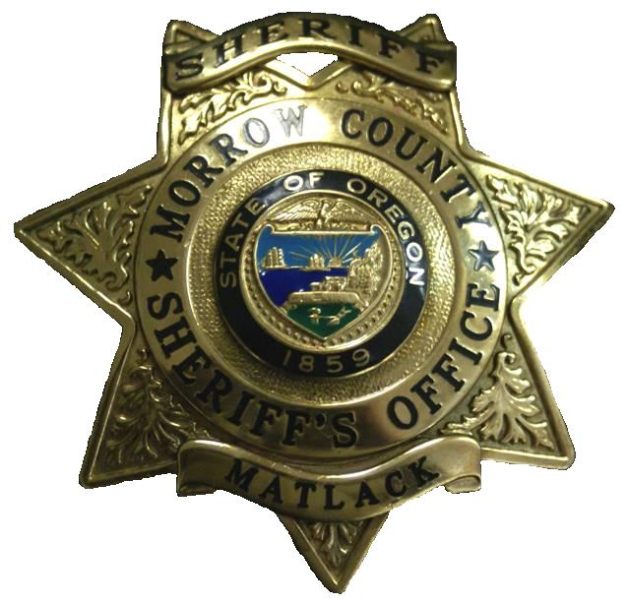
325 Willow View Drive -:- P.O. Box 159
Heppner, OR 97836
Phone: (541)676-5317
Fax: (541)676-5577
Kenneth W. Matlack, Sheriff
John A. Bowles, Undersheriff
MORROW COUNTY SHERIFF

The Morrow County Sheriff’s Office is accepting applications for Patrol Deputy for a hiring list for future openings.
Entry level minimum qualifications include: High school graduate or completed a GED program; must be 21 years of age; must be a U.S. citizen; must possess, or be able to obtain by time of hire, a valid Oregon Driver’s License without suspension or revocation in any state; successfully pass a drug test and full background investigation; shall not have been convicted of a felony or crime in which a maximum term of imprisonment of one year may be imposed; shall not have been convicted of a violation of any law involving narcotics; be of good moral and ethical character certifiable as a Police Officer in the state of Oregon based on standards established by the Oregon Department of Public Safety Standards and Training (DPSST); must successfully complete the Oregon Department of Public Safety Standard and Training (DPSST) basic police academy and 18 months probationary period. Must pass written test, oral interview and medical exam; must be able to communicate effectively, both orally and in writing.
Lateral hires must have current Oregon DPSST certification, or certification in another state with the ability to obtain Oregon Certification and three 3 years’ experience as a Police Officer/Patrol Deputy assigned to field duties. (Oregon certification preferred.)
Requires ability to work without direct supervision in emergencies, and exercise considerable independent judgment and discretion.
The position of patrol deputy requires the individual to be able to work any shift, any day, including weekends and holidays. Overtime and callouts may be required with very little notice. Individual should have a willingness to help citizens and businesses throughout the communities they serve.
This is a full time position with an excellent benefit package. Pay ranges from $3,613 to $3,996. Uniform & equipment furnished; medical & dental insurance; life insurance, retirement (equal to PERS); holiday pay; sick leave; vacation leave; certification incentive pay & assigned vehicle.
To apply: Applicants should submit a completed application available by contacting the Morrow County Sheriff’s Office at 541-676-5317. Applications can be sent out via email, fax or United States Postal Service or may be downloaded from the Morrow County website, www.co.morrow.or.us.
For additional details or questions, please contact Undersheriff John A. Bowles at 541-676-5317.
The Morrow County Sheriff’s Office is a veteran’s preference employer. All qualified applicants will receive consideration for employment without regard to race, color, religion, sex, national origin, disability status, protected veteran status, or any other characteristic protected under state, federal or local law.

