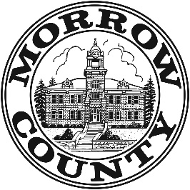
MORROW COUNTY BUDGET COMMITTEE MEETING

A public meeting of the Budget Committee of Morrow County, State of Oregon, to discuss the budget for the fiscal year July 1, 2025, to June 30, 2026, will be held at the Morrow County Bartholomew Building, 110 N. Court Street, Heppner, Oregon. The meeting will take place on May 22nd – 23rd, 2025. This meeting will span the two days listed above beginning on May 22th at 9:00 AM and resuming at 9:00 AM each day. The schedule for each day, once finalized, will be posted at www.morrowcountyor.gov.
The purpose of the meeting is to receive the budget message and to receive comments from the public on the budget.
These are public meetings where deliberations of the Budget Committee will take place. Any person may appear at the meeting and discuss the proposed programs with the Budget Committee.
The public may obtain a copy of the budget document after 9:00 AM on May 19th, at the Morrow County Bartholomew Building, 110 N. Court Street, Heppner, Oregon, between 9:00 a.m. and 5:00 p.m.; Monday - Friday. Please visit www.co.morrow.or.us/finance or call Kevin Ince, Budget Officer, at (541) 676-5615 for more information.

